In Release R4A, there will be 10 single phase (15min interval) and 15 poly phase smart meter that will be deployed to customers on GSD_1120 and GSD_1130 rate categories. These customers are being billed Power Factor either from the legacy meter that measures the Power Factor directly, or a default Power Factor. The registers on the legacy meter measures KWH, KW and PF, while the registers on the smart meters measures KWH, KW and KVARH. The new smart meters will no longer have a PF register, rather it will have a KVARH register. The KVARH consumption together with the KWH consumption will be used in calculating the power factor.
The device replacement workflow has been enhanced to process the legacy to smart meter device replacement. Enhancement includes aligning the register, allocating the transformer if needed, entering meter reads, and populating the rate types. The device replacement workflow is triggered once OMAR has completer the work orders.
In cases where there is an issue with the workflow processing, the meter replacement needs to be performed manually.
This job aid contains the steps that needs to be performed to process a manual device replacement.

Note the master data you will be needing for the device replacement:
- Installaton
- Old material number, old device number
- New material number, new device number
- Meter exchange date

From the SAP menu execute transaction EG30 to initiate device replacement
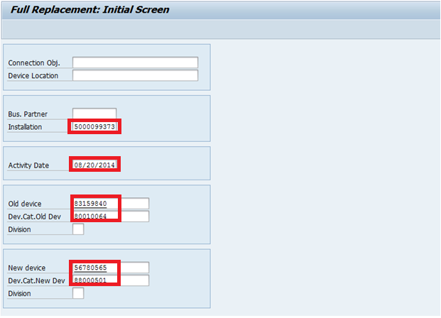
Populate Installation, Activity Date, Old device and its device category, New device and its device category
Click on Enter. This will take you to the Full Replacement screen.

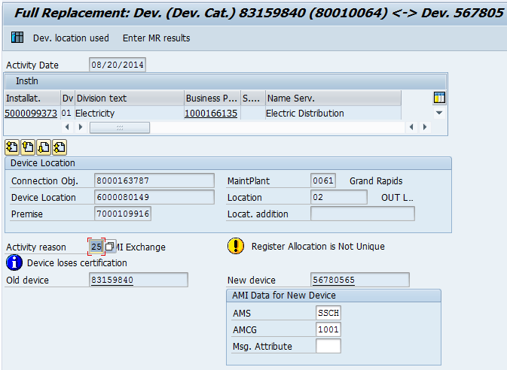
Enter Activity reason 25 for AMI Exchange.

Change Register Configuration
Goto Edit Change register configuration
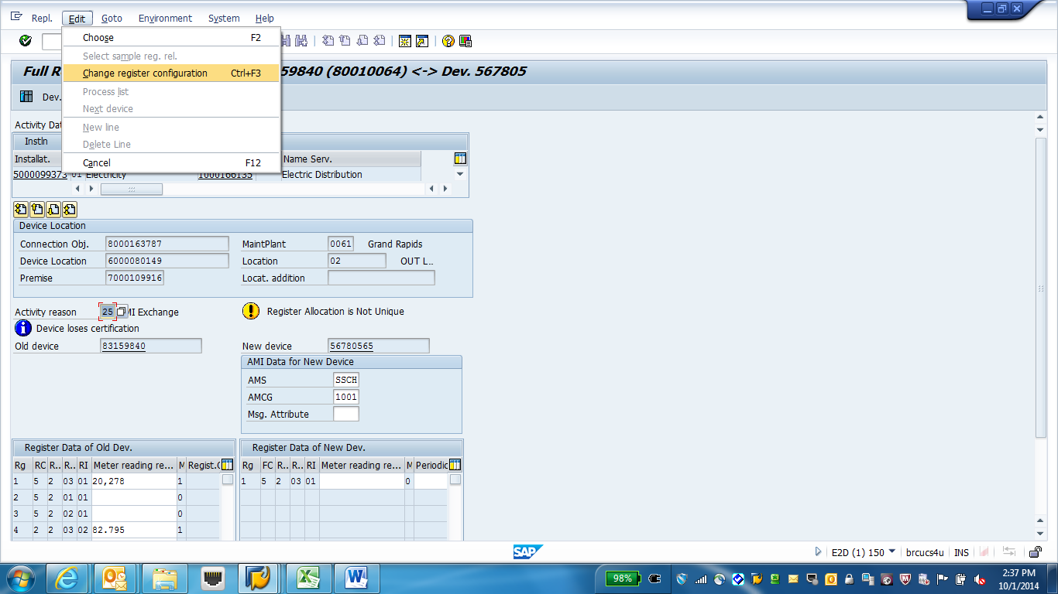

Pop-up will appear which allows you to activate/de-activate registers.
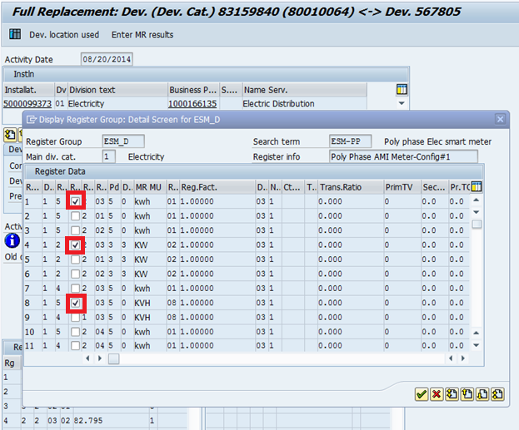
Activate registers 1 (kwh), 4 (KW) and 8 (KVH).
Click on Continue.
Enter Meter Reading Results
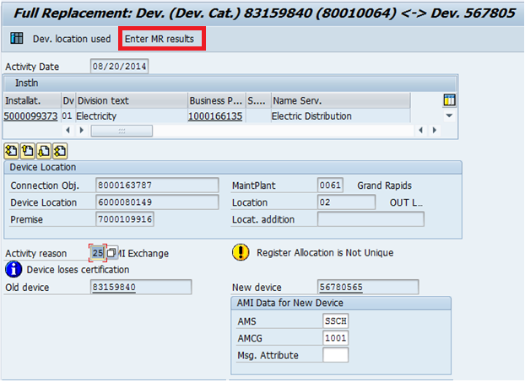
Click on Enter MR Results

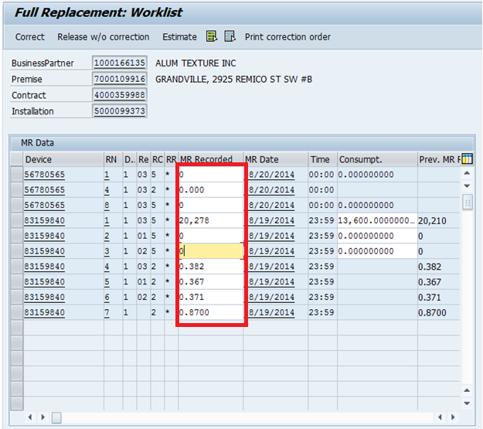
Enter MR Results for the new and old device, the click on the Back arrow.

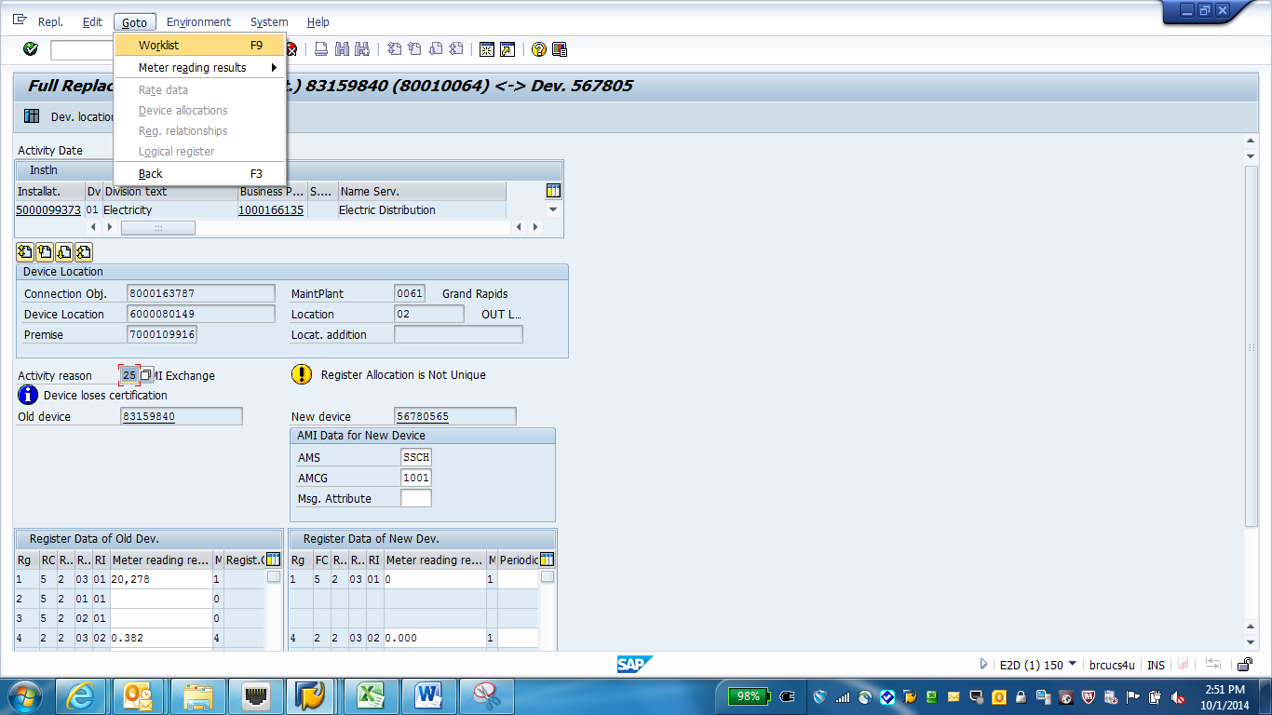
Goto Worklist
A pop-up box will be displayed asking if you want to save.
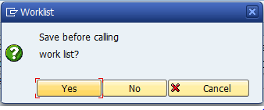
Click on Yes
Align the Logical Register Numbers
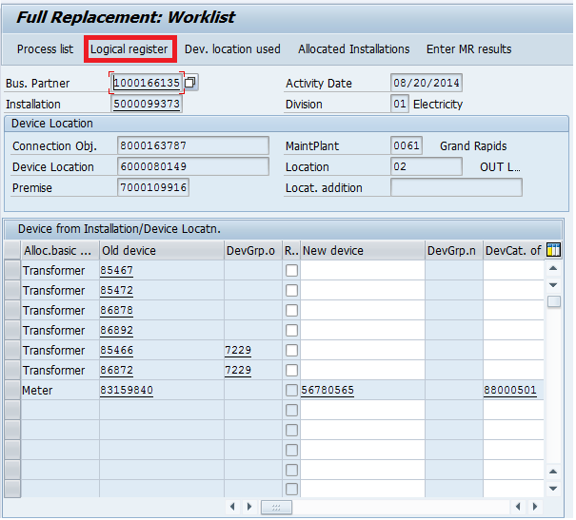
Click on Logical register
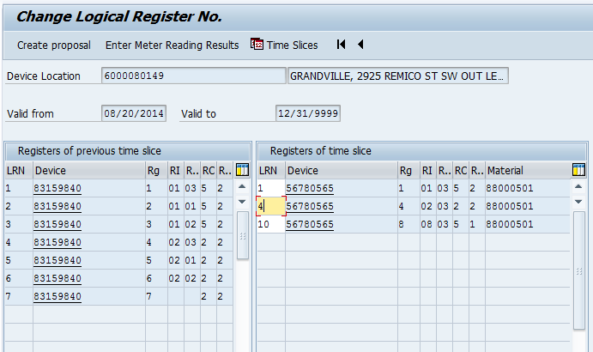
Align logical register number for registers 1 and 4. Leave Register 8 alone.
Click on the Back Button

Perform device allocation if needed
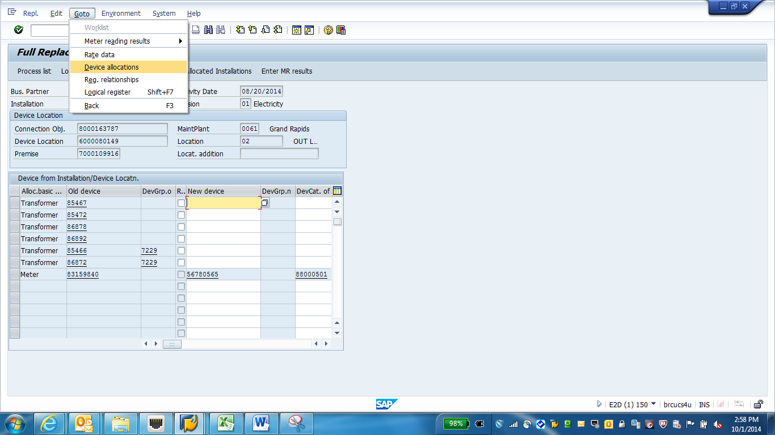
Goto Device allocations
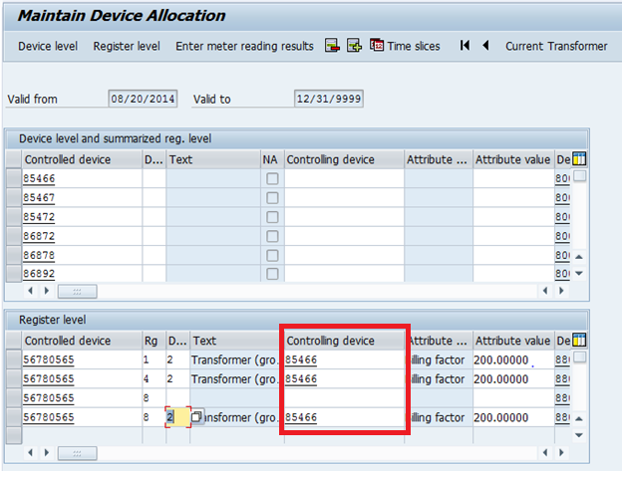
Populate Controlling device with the tansformer number. The controlling device for register 8 may already have been populated. Enter the same device to registers 1 and 4. Populate Device Allocation type with ‘02’ for Transformer (group).
Click on the Back button

Populate Rate Data
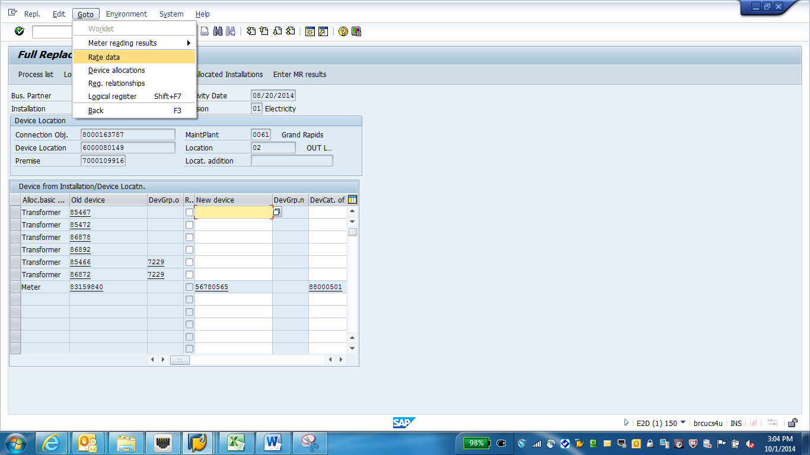
Goto Rate Data
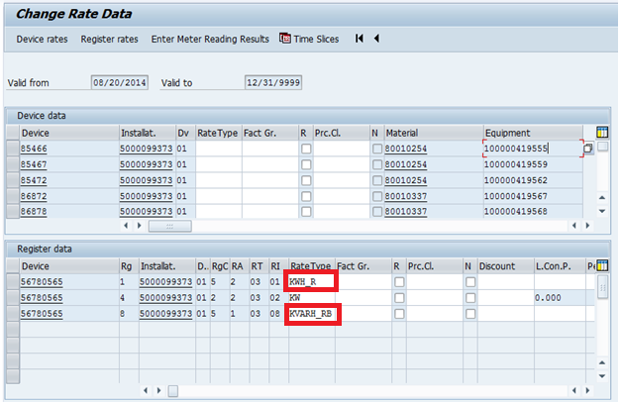
Set the Rate Type for Register 1 to KWH_R.
Set the Rate Type for Register 8 to KVARH_RB for billed power factor or KVARH_RR for read-only default power factor.

Note: The KVARH rate types are only applicable for GSD_1120 and GSD_1130 customers. For customers that is being billed based on a PF register consumption, use rate type KVARH_RB. For customers being billed a default PF and either do not have a PF register or has a PF register that is set to ‘Not relevant for billing’, use rate type KVARH_RR.

Click on the Back button to get to the Full Replacement Worklist
Click on Save.
A pop-up will appear if you have any errors, otherwise you will get a success message that the device replacement has been completed.
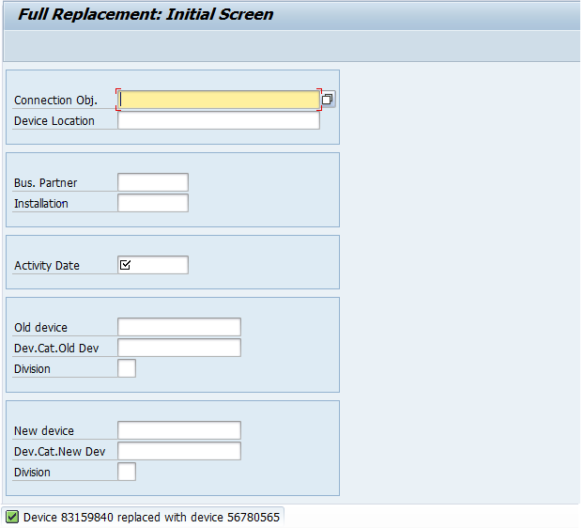

Revision History
Version | Author(s) | Date | Significant Changes
0.1 | Mary Jane Afable | 10/01/14 | Initial Document Release

